FIRST 2022 27th year!!! Oh Yeah!!!

Team Meeting 3/11/21 FIRST Website-www.firstinpires.org Team website-www.tj2.org
-------------------------------------------------------------------------------------------------------------------------------
Student Leadership Board: Grant W. (Captain), Rohan S., Evan G., Emma O.
Coaches , Engineers & Volunteers: Mrs. Calef ( Lcalef@bridge-rayn.org),Mrs. Hall (anniem81949@yahoo.com), Ms. Jerome, Mr. Jahnke, Mr. Stewart, Mrs. Wood, Mr.Delmonte, Mr. Calef, Mr. LaMothe, Jen Flannery, Mr. Nick Avtges, Pat Koczela, Tom Calef, Steve Viera, Heather Charland, Doug Stewart, Brad Wall, Amy Sauger, Eric Theberge, Mrs. Theberge, Trevor Kelly, Paul Terrasi, Dr. Joe Johnson , Ben Warwick, Andras Pungor, Bob Spurr, Shay Mitton, Maggie Taylor, Jose Comi
Friends of TJ2 Robotics -FOTJ2R – a 5013C friends support group - President: Scott Rubin, Treasurer: Kerri Spurr, Secretary: Heather Charland – Board of Directors: Bill Wood, Heather Charland, Brad Wall, Nick Avtges, Eric Theberge, Doug Stewart, Scott Rubin, Bob Spurr, Kerri Spurr, Don DeLutis, and Gretchen DeLutis.
Twitter page https://twitter.com/frcteam88 Google Classroom : z6pvwas
-------------------------------------------------------------------------------------------------------------------------------
ATTENTION: When shopping on Amazon.com, if instead you go to www.smile.amazon.com and declare Friends of TJ2 Robotics, Inc., your charity…..0.5% of every purchase will to FOTJ2R without costing you anything!!!!! Please tell all your family and friends.
Team Meetings: Fridays bi-weekly at 2:15pm BRRHS Rm H103 , next meeting 3/25/22
Meeting agendas will be posted on our website at https://www.tj2.org/team-meetings
Team Ranking - based on logged and approved hours recorded on Google Form. Team travel will be determined by number allowed to travel and ranked student list.

FIRST Scholarship - Open Date: Wednesday, September 1, 2021 -APPLY APPLY APPLY!!!!

ATTENTION: Your school has approved these trips as field trips. Your mentors and your teachers are expecting you to show how much you value these experiences by responsibly staying up to date in all of your classes. These trips are not to be used as an excuse for late work. If you can not keep up with your school work, you need to step back from the team and meet your responsibilities. If this continues to be an issue, we won’t be able to go on these trips. Do not ruin this for your team.

Group Meetings-
TJ² Art – Mondays- BRRHS Rm B204 2:15-4pm
Tshirt update- 100+ shirts dyed and going to printer this week
Jackets for rookie members available now -pass out jackets
FIRST Registration form: incomplete for Joe B, Travis C, Nate B, AJ R, Jamisen S, PJ S.
Please complete this by 3/13 if you are traveling to North Shore.
Link to North Shore Itinerary: North Shore TJ2 Itinerary 2022
Hotel rooming list: after trip info on this itinerary
NE Consent & Release required of all attending members. https://www.firstinspires.org/resource-library/frc/district-consent-and-release-form

TJ² PR – Tuesdays- BRRHS D138 6-7pm alternate Tuesdays-full team effort needed on these!!!
Chairman’s update from Granite State- Chairman’s video
https://drive.google.com/file/d/1pdcRL6OIjcQx9C3mCBSSEyFjaFCj77Ul/view?usp=drivesdk
Sponsors? If you know of companies that could sponsor us contact Mrs. Calef
At lcalef@bridge-rayn.org BEFORE you contact the company
QR codes to log hours

TJ² CAD –During build meetings until robot design is done! BRRHS D138
TJ² Programming -during build sessions
Programming and ROS update- show video

Scouting update from Granite State, heatmap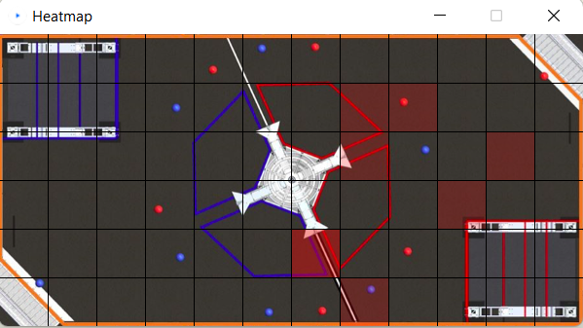
TJ² Team Meetings – biweekly Fridays – BRRHS H103 2:15-2:40
TJ² Build – ON CALENDAR
Build update from Granite State -Match video https://www.thebluealliance.com/match/2022nhgrs_qm41

SPOTLIGHT- Robot status and competition going forward

Upcoming Team Events: https://www.tj2.org/competition-information
Event schedules are on the website

NORTH SHORE EVENT - 25 passengers, luggage, supplies, robot
North Shore Itinerary Link on slack #general , classroom
NE Consent & Release required of all attending members. https://www.firstinspires.org/resource-library/frc/district-consent-and-release-form
Reading Memorial High School, 62 Oakland Road, Reading, MA 01867 USA
Friday Mar 18 Leave BRRHS at 3:30pm to go to Reading HS. Leave Reading HS at 9pm to go to BRRHS by 11pm
Saturday Mar 19 Students come at 6:15am, Leave BRRHS at 6:30am to go to Reading HS. Leave Reading HS at 8pm to go to BRRHS by 10pm
Sunday Mar 20 Students come at 6:15am, Leave BRRHS at 6:30am to go to Reading HS. Leave Reading HS at 6pm to go to BRRHS by 8pm

HARTFORD EVENT- 25 passengers, luggage, supplies, robot
Hartford Public High School, 55 Forest St, Hartford, CT 06105 USA
*Friday April 8 Leave BRRHS at 1:00pm to go to hotel (TBD). Go to Hartford HS at 4:30pm. Leave Hartford HS at 9pm to go to area hotel TBD
Saturday April 9 Leave hotel at 7:30am to go to Hartford HS. Leave Hartford HS at 8pm to go to hotel
Sunday April 10 Leave hotel at 7:30am to go to Hartford v HS. Leave Hartford HS at 6pm to go to BRRHS by 9pm

NE CHAMPIONSHIP - (If we qualify) 45 passengers, luggage, supplies
BIG E -Eastern States Exposition, 1305 Memorial Ave, West Springfield, MA 01089 USA.
Hotel Hampton Inn West Springfield 1011 Riverdale St. West Springfield, MA 1-413-737-1300
*Wednesday April 13 Leave BRRHS at 1:00pm to go to hotel . Go to BIGE at 4:30pm. Leave BIGE at 9pm to go to hotel
*Thursday April 14 Leave hotel at 6:30am to go to BIGE . Leave BIGE at 8pm to return to hotel.
*Friday April 15 Leave hotel at 6:30am to go to BIGE . Leave BIGE at 8pm to return to hotel.
Saturday April 16 Leave hotel at 6:30am to go to BIGE . Leave BIGE at 7pm to return BRRHS by 10pm.

WORLD CHAMPIONSHIP (if we qualify) 45 passengers, luggage, supplies during April vacation.
Tuesday April 19 -BRRHS TBD to go to Logan Airport TBD
Sunday April 24 - Logan Airport TBD to BRRHS

Hotel Room Assignments: these can change, but they are holding our rooms for now. Email me at lcalef@bridge-rayn.org if there are any issues. These rooms have 2 queen size beds.

Adult: Room1 – Elizabeth Calef, Virginia Jerome, Anne Delmonte
Adult: Room2- Ben Warwick, Jinling Sun, Dr. Joe Johnson
Adult: Room 3- Bob Spurr, Kerri Spurr
Adult: Room 4- Andras Pungor, John Stewart, Nick Avtges
Adult: Room 5-Paul Terasi, Trevor Kelly, Bill Wood
Adult: Room 6- Doug Stewart, Steve Viera, Brad Wall
Adult: Room 7- Jen Flannery, Amy Sauger, Heather Charland
Student: Room 8- Grant Watson, Justin Delutis, Evan Gagnon, Anthony Marchetti
Student: Room9- Adam Duhamel, Andrew Martin, Evan Spurr, Alex Nenopolous
Student: Room 10- Cole Faunce, Owen Gagnon, Ben Manchester-Howell, Max Meoli
Student: Room 11- Emma Onwumere, Megan Aronoff
Student: Room12-Rohan Sekhri, Tucker McGrath, John Morrissey, Travis Conley
Student: Room 13-DJ Cox, AJ Robbins
Busdriver: Room 14.

Code of Ethics -what is expected of all TJ² members - https://www.tj2.org/codeofethics
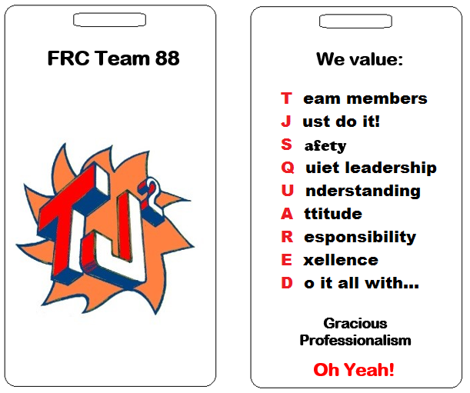
Keep up with TJ²
Check Google Classroom consistently
Check Google Calendar
Follow Slack - contact Steve Viera if issues - steven.viera88@gmail.com
Vote: Team review and vote for amended code of ethics.
Proposed change: for J- Just have fun!

