FIRST 2022 27th year!!! Oh Yeah!!!

Team Meeting 11/5/21 FIRST Website-www.firstinpires.org Team website-www.tj2.org
-------------------------------------------------------------------------------------------------------------------------------
Officers:
Coaches , Engineers & Volunteers: Mrs. Calef ( Lcalef@bridge-rayn.org),Mrs. Hall (anniem81949@yahoo.com), Ms. Jerome, Mr. Jahnke, Mr. Stewart, Mrs. Wood, Mr.Delmonte, Mr. Calef, Mr. LaMothe, Jen Flannery, Mr. Avtges, Pat Koczela, Tom Calef, Steve Viera, Heather Charland, Doug Stewart, Brad Wall, Amy Sauger, Eric Theberge, Mrs. Theberge, Trevor Kelly, Paul Terasi, Dr. Joe Johnson , Ben Warwick, Andras Pungor, Bob Spurr, Shay Mitton
Friends of TJ2 Robotics -FOTJ2R – a 5013C friends support group - President: Scott Rubin, Treasurer: Kerri Spurr, Secretary: Heather Charland – Board of Directors: Bill Wood, Heather Charland, Brad Wall, Nick Avtges, Eric Theberge, Doug Stewart, Scott Rubin, Bob Spurr, Kerri Spurr, Don DeLutis, and Gretchen DeLutis.
Twitter page https://twitter.com/frcteam88 Google Classroom : z6pvwas
-------------------------------------------------------------------------------------------------------------------------------
ATTENTION: When shopping on Amazon.com, if instead you go to www.smile.amazon.com and declare Friends of TJ2 Robotics, Inc., your charity…..0.5% of every purchase will to FOTJ2R without costing you anything!!!!! Please tell all your family and friends.
Team Meetings: Fridays bi-weekly at 2:15pm BRRHS Rm H103 , next meeting 11/19/21
Meeting agendas will be posted on our website at https://www.tj2.org/team-meetings

Group Meetings-
TJ² Build Training -Fridays – BRRHS Rm D134 2:15-4:30pm
TJ² Art – Mondays- BRRHS Rm B204 2:15-4pm
TJ² PR – Tuesdays- zoom or JA 6-7pm (see calendar for location)
TJ² CAD –Tuesdays- Zoom – 7-8pm
TJ² Programming – Wednesdays – Zoom 7-8pm
TJ² Strategy – Thursdays – JA 5:30-6pm
TJ² Project Build – Thursdays – JA 6-8pm
TJ² Team Meetings – biweekly Fridays – BRRHS H103 2:15-2:40
TJ² Build – Saturdays as announced – refer to build slack channel and calendar

River Rage – 2nd place finish!!! Oh Yeah!!! Diffy Jr successfully navigated a real FIRST field too!!!
Great Day!!!

Officer Elections – Student Leadership board: Grant W., Rohan S., Evan G., Emma O.
TJ² 2022 Captain -

Hours – keep tracking your hours. – group, date, time, # hours, group leader initial

Upcoming Team Events:
Jan 8th – Mandatory meeting for all members of TJ2- 9:30-12:00pm. Voluntary discussions Saturday afternoon. Location TBD
Jan 9th – Mandatory meeting for all members of TJ2 – 12-3pm. Location TBD
March 3-5th- Granite State New England District Event - commute
March 18-20 – North Shore New England District Event -commute
April 8-10 – trying to sign up for a week 6 event -possible hotel stay
Strategy – build good robot and run in first two events. Determine and fix bugs and upgrade to
District Championship caliber robot and compete in week 6 event to practice for District Championship
April 13-16 – New England District Championship Location TBD possible hotel stay
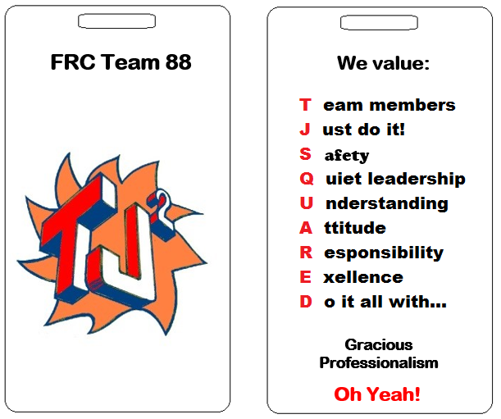
Code of Ethics -what is expected of all TJ² members

TJ² Member Code
General Guidelines for Team member
• Contribute to welcoming atmosphere and feel of the team
• Do not misuse team or school equipment/facilities
• Value honesty and integrity
• Absolutely never bully, exclude, or discriminate against teammates, members of FIRST Robotics or anyone
• Have knowledge of all rules and regulations both in your school and at FIRST events and report any violations of them
• Fulfill all obligations and responsibilities to the best of your ability
• Accept responsibility for your actions
• Understand and follow the general ethics rules of FIRST
• Code of Conduct FIRST Robotics

Keep up with TJ²
Check Google Classroom consistently
Check Google Calendar
Follow Slack

