FIRST 2022 27th year!!! Oh Yeah!!!

Team Meeting 1/8/21 FIRST Website-www.firstinpires.org Team website-www.tj2.org
-------------------------------------------------------------------------------------------------------------------------------
Student Leadership Board: Grant W. (Captain), Rohan S., Evan G., Emma O.
Coaches , Engineers & Volunteers: Mrs. Calef ( Lcalef@bridge-rayn.org),Mrs. Hall (anniem81949@yahoo.com), Ms. Jerome, Mr. Jahnke, Mr. Stewart, Mrs. Wood, Mr.Delmonte, Mr. Calef, Mr. LaMothe, Jen Flannery, Mr. Nick Avtges, Pat Koczela, Tom Calef, Steve Viera, Heather Charland, Doug Stewart, Brad Wall, Amy Sauger, Eric Theberge, Mrs. Theberge, Trevor Kelly, Paul Terrasi, Dr. Joe Johnson , Ben Warwick, Andras Pungor, Bob Spurr, Shay Mitton, Maggie Taylor, Jose Comi
Friends of TJ2 Robotics -FOTJ2R – a 5013C friends support group - President: Scott Rubin, Treasurer: Kerri Spurr, Secretary: Heather Charland – Board of Directors: Bill Wood, Heather Charland, Brad Wall, Nick Avtges, Eric Theberge, Doug Stewart, Scott Rubin, Bob Spurr, Kerri Spurr, Don DeLutis, and Gretchen DeLutis.
Twitter page https://twitter.com/frcteam88 Google Classroom : z6pvwas
-------------------------------------------------------------------------------------------------------------------------------
ATTENTION: When shopping on Amazon.com, if instead you go to www.smile.amazon.com and declare Friends of TJ2 Robotics, Inc., your charity…..0.5% of every purchase will to FOTJ2R without costing you anything!!!!! Please tell all your family and friends.
Team Meetings: Fridays bi-weekly at 2:15pm BRRHS Rm H103 , next meeting 1/14/22
Meeting agendas will be posted on our website at https://www.tj2.org/team-meetings
Team Ranking - based on logged and approved hours recorded on Google Form. Team travel will be determined by number allowed to travel and ranked student list.

FIRST Scholarship - Open Date: Wednesday, September 1, 2021 -APPLY APPLY APPLY!!!!
Dean’s List - Mentor submission- Open Date: Thursday, November 4, 2021 at 12:00 PM (noon) Eastern Time
Close Date: Thursday, February 10, 2022 at 3:00 PM Eastern Time

Group Meetings-
TJ² Art – Mondays- BRRHS Rm B204 2:15-4pm
TJ² PR – Tuesdays- BRRHS D138 6-7pm alternate Tuesdays-full team effort needed on these!!!
WFA- Open Date: Thursday, November 4, 2021 at 12:00 PM (noon) Eastern Time
Close Date: Thursday, February 10, 2022 at 3:00 PM Eastern Time
TJ² CAD –During build meetings until robot design is done! BRRHS D138
TJ² Programming – Wednesdays – Zoom 7-8pm and during build meetings as needed.
TJ² Strategy – Thursdays – BRRHS 5:30-6pm D138
TJ² Team Meetings – biweekly Fridays – BRRHS H103 2:15-2:40
TJ² Build – Tuesday and Thursdays BRRHS D134 5:30-8:30pm,
Saturdays 9-5pm :Jan 15, 22, 29, Feb 5, Feb 12, Feb19, Feb 26
Sundays Feb 6 9-5, Feb13 9-3, Feb 20 9-5, Feb 27 9-5
Drive practice and Driver selection will happen at TJA when possible (Feb1 and on???)
WATCH CALENDAR FOR UPDATES

TJ²Art Group - 2022 Uniforms!!! - Let’s vote for the pattern you will be wearing!!!!

SPOTLIGHT- Kickoff
Upcoming game- teasers:
Episode 1 https://www.youtube.com/watch?v=XmTSXEkGrVw
Episode 2 https://www.youtube.com/watch?v=sgvAAzhD-n4
Episode 3 https://www.youtube.com/watch?v=9PJ5RDuPVOs
Episode 4 https://www.youtube.com/watch?v=Fte2XnDfmgA
Saturday, Jan 8 11:30-2pm- Location BRRHS Lecture Hall
Sunday, Jan 9 noon - 3pm - Location BRRHS Lecture Hall
New Sponsor Update Thankyou!!!!
Amazon-amount ???
Naming update - JA (jedi Academy) is now TJA (TJ Academy)
Location: Market Basket, Rte. 138, Raynham, MA
Jan 9th – Mandatory meeting for all members of TJ² – 12-3pm.
Mentors and Captains 3-5pm. Location BRRHS Lecture Hall
Upcoming Team Events: https://www.tj2.org/competition-information
March 3-5th- Granite State New England District Event - commute
March 18-20 – North Shore New England District Event -commute
Team Strategy – build good robot and run in first two events.
April 8-10 - Hartford New England District Event
Determine and fix bugs and upgrade to District Championship caliber robot for District Championship
April 13-16 – New England District Championship Location (TBD possible hotel stay- travel by bus - student payment probably required)
April 20-23 - Houston, TX - World Championship if we qualify with travel days (April 19-24 by plane - student payment probably required)

Code of Ethics -what is expected of all TJ² members - https://www.tj2.org/codeofethics
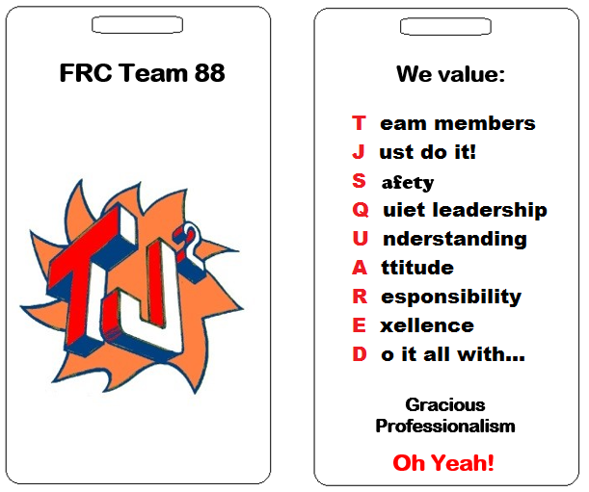
Keep up with TJ²
Check Google Classroom consistently
Check Google Calendar
Follow Slack - contact Steve Viera if issues - steven.viera88@gmail.com

Kickoff Agenda -
Saturday
11:30-11:45- team meeting agenda review
11:45 - Captains/Wall/Viera/Johnson - what are we looking for in game rules
1pm or after broadcast - break into groups and study rules
2pm - meet to discuss rules - What is the game?
3pm - Strategy / Gameplay - Break into groups - How is the game played? What should our robot do?
4pm- Group presentations on what our robot should do and why!
Sunday
12pm - Rules Kahoot game for Team rule understanding
1pm - Break into groups for how robot will play game based on Saturday discussion
2pm - Group robot presentations
3pm - Students dismissed - Captains and Mentors make plans for accomplishing robot tasks.

