The TJ², Bridgewater Raynham High School robotics team is a competitively ranked team in New England. 42 high school students work with 32 mentors to build a 150 pound robot to compete in a game that will be revealed to us on January 7th by the FIRST organization. The goals of FIRST are to get high school students excited to work in Science, Technology, Art, and Mathematics fields. Mentors work with students to design, build, and fabricate robots using state of the art tools and software packages that prepare them for future careers in these fields. Students also learn to present themselves and their work through a variety of media platforms. The team then travels to multi day competitions as far away as Houston, TX for the World Championship that we qualified for and attended last year.
This is where YOU can help. We appreciate any monetary donation that you can give to our team. Checks can be made out to our 501(c)3, “FOTJ2R, Inc.” Your tax deductible donation will make a meaningful impact on a student’s experience. For example, a $100 donation will cover a hotel room for a student and a $500 dollar donation will cover a student’s round trip flight. Any donation will help inspire a local student and send them full S.T.E.A.M ahead!
Thank You!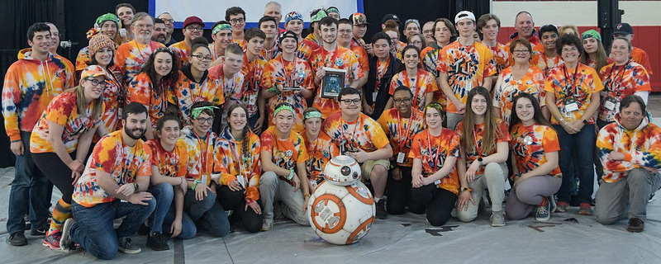
FIRST – For Inspiration and Recognition of Science and Technology – www.firstinspires.org
Friends of TJ2 Robotics, Inc.
Tax ID# 47-4739521
P.O. Box 834
Bridgewater, MA. 02324
Telephone: 508-631-7106
Email: fotj2r@gmail.com

Visit our team website at www.tj2.org for more information about our team and who your donation will benefit!

