FIRST 2022 27th year!!! Oh Yeah!!!

Team Meeting 12/3/21 FIRST Website-www.firstinpires.org Team website-www.tj2.org
-------------------------------------------------------------------------------------------------------------------------------
Student Leadership Board: Grant W. (Captain), Rohan S., Evan G., Emma O.
Coaches , Engineers & Volunteers: Mrs. Calef ( Lcalef@bridge-rayn.org),Mrs. Hall (anniem81949@yahoo.com), Ms. Jerome, Mr. Jahnke, Mr. Stewart, Mrs. Wood, Mr.Delmonte, Mr. Calef, Mr. LaMothe, Jen Flannery, Mr. Avtges, Pat Koczela, Tom Calef, Steve Viera, Heather Charland, Doug Stewart, Brad Wall, Amy Sauger, Eric Theberge, Mrs. Theberge, Trevor Kelly, Paul Terasi, Dr. Joe Johnson , Ben Warwick, Andras Pungor, Bob Spurr, Shay Mitton
Friends of TJ2 Robotics -FOTJ2R – a 5013C friends support group - President: Scott Rubin, Treasurer: Kerri Spurr, Secretary: Heather Charland – Board of Directors: Bill Wood, Heather Charland, Brad Wall, Nick Avtges, Eric Theberge, Doug Stewart, Scott Rubin, Bob Spurr, Kerri Spurr, Don DeLutis, and Gretchen DeLutis.
Twitter page https://twitter.com/frcteam88 Google Classroom : z6pvwas
-------------------------------------------------------------------------------------------------------------------------------
ATTENTION: When shopping on Amazon.com, if instead you go to www.smile.amazon.com and declare Friends of TJ2 Robotics, Inc., your charity…..0.5% of every purchase will to FOTJ2R without costing you anything!!!!! Please tell all your family and friends.
Team Meetings: Fridays bi-weekly at 2:15pm BRRHS Rm H103 , next meeting 12/17/21
Meeting agendas will be posted on our website at https://www.tj2.org/team-meetings
Team Ranking - based on logged and approved hours recorded on Google Form. Team travel will be determined by number allowed to travel and ranked student list.
Group Meetings-
TJ² Build Training -Fridays – BRRHS Rm D134 2:15-4:30pm
TJ² Art – Mondays- BRRHS Rm B204 2:15-4pm
TJ² PR – Tuesdays- zoom or JA 6-7pm (see calendar for location)
TJ² CAD –Tuesdays- Zoom – 7-8pm
TJ² Programming – Wednesdays – Zoom 7-8pm
TJ² Strategy – Thursdays – JA 5:30-6pm
TJ² Project Build – Thursdays – JA 6-8pm
TJ² Team Meetings – biweekly Fridays – BRRHS H103 2:15-2:40
TJ² Build – Saturdays as announced – refer to build slack channel and calendar

SPOTLIGHT- Art
Team Colors
Uniforms and meaning
Rookie Jackets -make sure your size is correct with Ms. Jerome.
Cheering accessories
Tie dye possibilities
Sample tie dye shirts to show off

Holiday Party...after team meeting 12/17. Bring a snack and a gift for the swap that is less than $10 in value.

Holiday Spirit…. Bring in a gift for the NHS Toys for Tots drive to Ms Jerome by 12/10 (next Friday). Since you didn’t fund raise this year it would be nice to “give back” to our community that has been so supportive of our efforts. Let’s spread the good spirit of our team!

Naming update - JA (jedi Academy) is now TJA (TJ Academy)
Location: Market Basket, Rte. 138, Raynham, MA
Build Season - Jan 8 - Mar 2
Build meetings - Tues, Thu 5:30-8:30 at BRRHS Rm D134, Sat 8-5pm (hopefully) Sun 10-3pm as needed (hopefully)
Drive practice at TJA when robot has developed to that level
Wed zoom program meetings will continue, Mon Art meetings will continue,
PR and Strategy meetings need to be scheduled. CAD meetings stop. Build Training meetings stop. Team Meetings continue. All meetings will be scheduled on the team calendar.

Upcoming Team Events:
Jan 8th – Mandatory meeting for all members of TJ²- 9:30-12:00pm. Voluntary discussions Saturday afternoon. Location TBD
Jan 9th – Mandatory meeting for all members of TJ² – 12-3pm. Location TBD
March 3-5th- Granite State New England District Event - commute
March 18-20 – North Shore New England District Event -commute
Team Strategy – build good robot and run in first two events.
April 8-10 - Hartford New England District Event
Determine and fix bugs and upgrade to
District Championship caliber robot for District Championship

April 13-16 – New England District Championship Location (TBD possible hotel stay- travel by bus - student payment probably required)
April 20-23 - Houston, TX - World Championship if we qualify with travel days (April 19-24 by plane - student payment probably required)

Code of Ethics -what is expected of all TJ² members
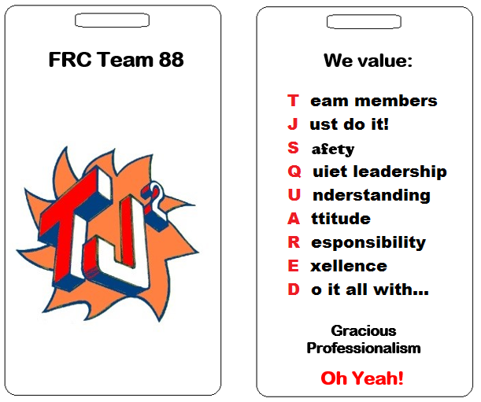

General Ethics for Leaders (Read and discuss meaning with team)
• Encourage the team and help members in understanding their own roles and ethics
• Help create opportunities for others to learn and experience all aspects of FIRST and STEAM as a whole
• Assist struggling or isolated members as well as develop trust with everyone
• Role model acceptable behavior by following all ethical rules and promoting an environment of toleration and acceptance
• Communicate and interact with all members and aspects of the team
Ethics for Competitions
• Always act with Gracious Professionalism
• Help others whenever you get the chance
• Treat other teams with respect and kindness
• Lift others up rather than tear them down
• Always keep your cool
• Do your best
• Behave responsibly

Keep up with TJ²
Check Google Classroom consistently
Check Google Calendar
Follow Slack

