FIRST 2022 28th year!!! Oh Yeah!!!

Team Meeting 2/28/23 FIRST Website-www.firstinpires.org Team website-www.tj2.org
-------------------------------------------------------------------------------------------------------------------------------
Student Leadership Board: Grant W.(Captain) , Rohan S., Evan G. Nathaniel B., Evan S., Silver D., Ben M-H.
Coaches , Engineers & Volunteers: Mrs. Calef ( Lcalef@bridge-rayn.org),Mrs. Delmonte, Ms. Jerome, Mr. Jahnke, Mr. Stewart, Mrs. Wood, Mr.Delmonte, Mr. Calef, Mr. LaMothe, Jen Flannery, Mr. Nick Avtges, Pat Koczela, Tom Calef, Steve Viera, Heather Charland, Doug Stewart, Brad Wall, Amy Sauger, Eric Theberge, Mrs. Theberge, Trevor Kelly, Paul Terrasi, Dr. Joe Johnson , Ben Warwick, Dr. Andras Pungor, Bob Spurr, Kerri Spurr, Shay Mitton, Connor Spurr
Friends of TJ2 Robotics -FOTJ2R – a 5013C friends support group - President: Scott Rubin, Treasurer: Kerri Spurr, Secretary: Heather Charland – Board of Directors: Bill Wood, Heather Charland, Brad Wall, Nick Avtges, Eric Theberge, Doug Stewart, Scott Rubin, Bob Spurr, Kerri Spurr, Don DeLutis, and Gretchen DeLutis.
Google Classroom : z6pvwas Calendar www.tj2.org/calendar
-------------------------------------------------------------------------------------------------------------------------------ATTENTION:
Amazon smile donation program has been discontinued effective 2/20/23.
Team Meetings: Fridays bi-weekly at 2:15pm BRRHS Rm H103
3/10, 3/24, 4/14, 5/5, 5/19, 6/2 (elections)
Meeting agendas will be posted on our website at https://www.tj2.org/team-meetings
FIRST Scholarships - https://www.firstinspires.org/alumni/scholarships
Team Funding Status: at this time have the funding for a trip to Houston! Continue to talk to your families to see if their business or employers could sponsor our team. Contact community businesses for support. See Ms. Jerome. Fundraising letter: TJ2 Fundraising letter 2023.docx
We have sooooooo many business friends that have not been contacted……good job for all of those that helped to change our status! Oh Yeah!!

Team Registration Status
Please make sure you are registered in STIMS and that your C&R form is signed.
https://docs.google.com/spreadsheets/d/1vwmpJ5K4k85sdp9UacXaeqUgTffF9O3RkWdOQfsXvlQ/edit?usp=sharing

AMAZON visit-
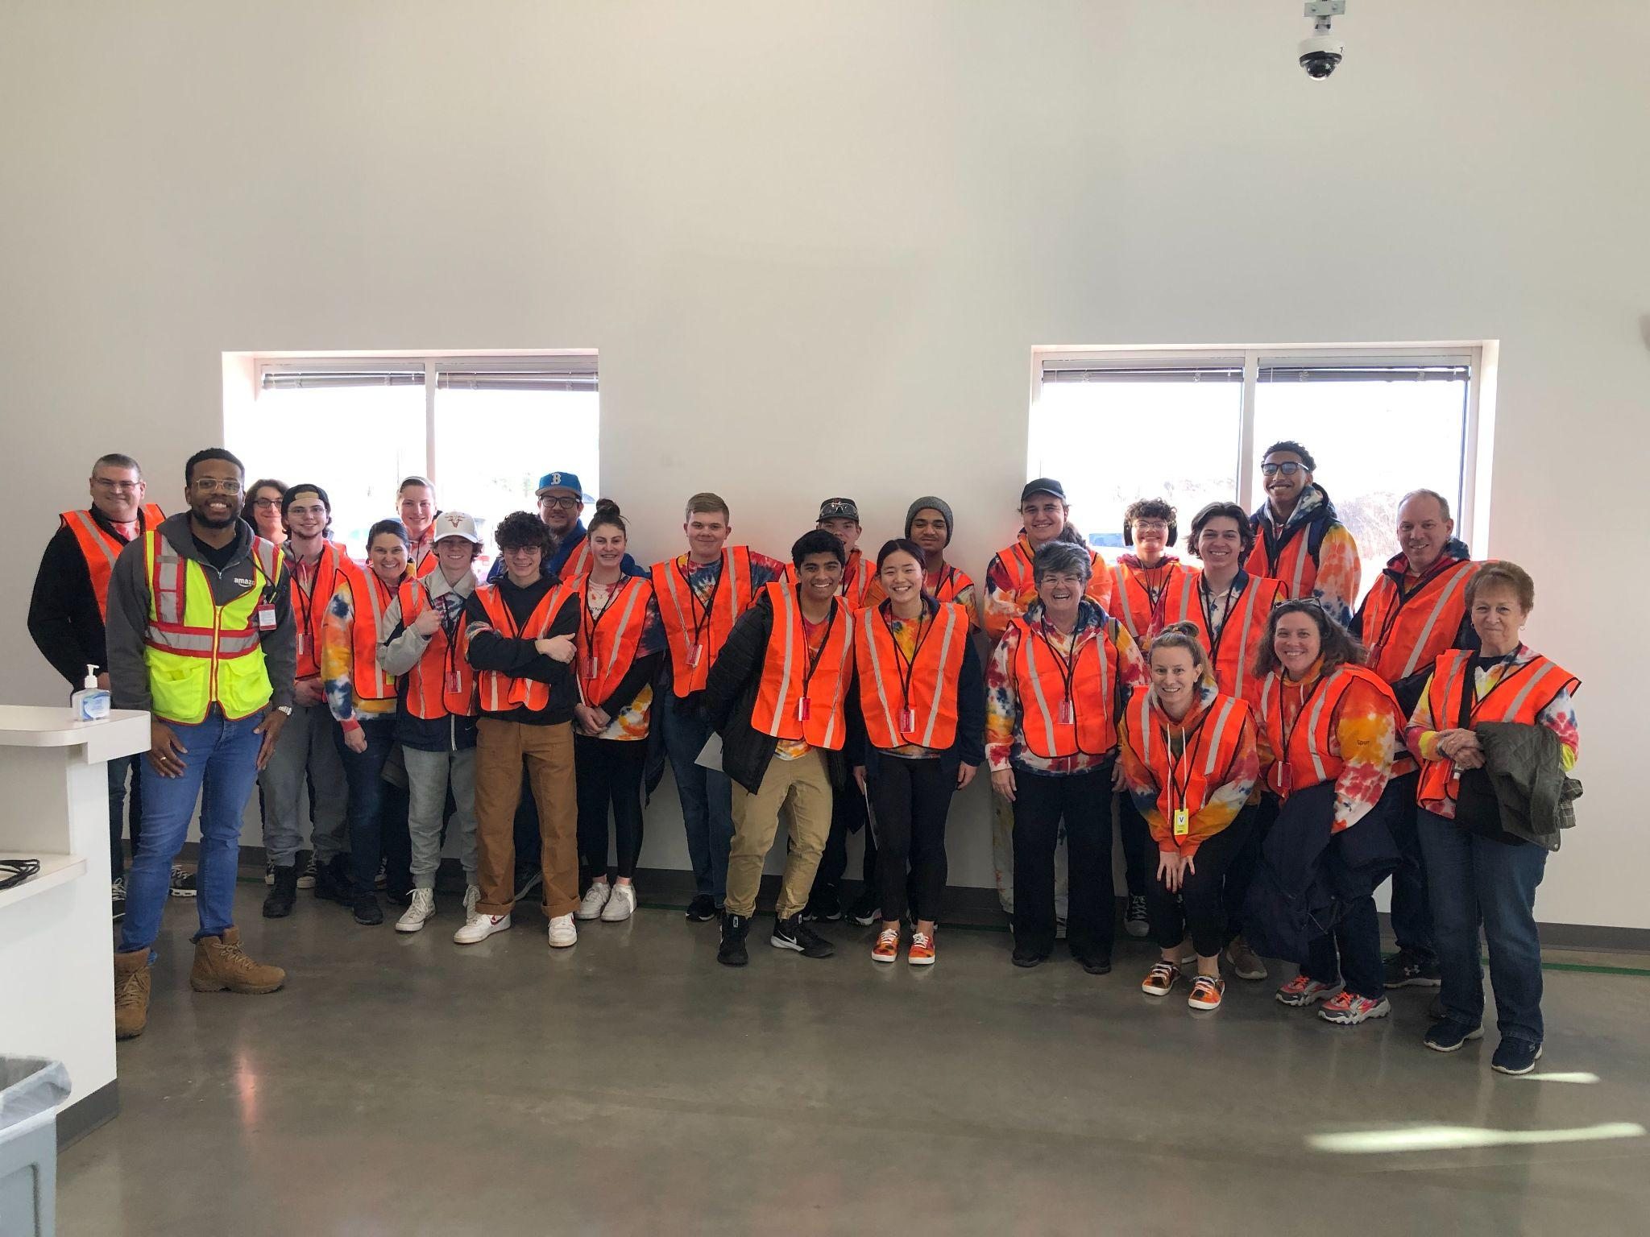
Group Meetings - log hours- use QR scan- should be in group meeting rooms
Veterans -min 30 hours, Rookies- min 20 hours to be on the travel team. Team meetings do not count. PR/Outreach hours count double You do not need to attend all of these meetings. You need to attend the team meetings on Friday. You may and are welcome to choose to attend any of the group meetings listed above. Ranking status -2023 TJ2 Ranking for Public View

Award Deadlines:
Dean’s List Award - Feb 9, 2023 at 3pm ETSilver & Owen
Woodie Flower’s Award - Feb 9, 2023 at 3pm ET

FIRST Impact Award -Feb 16, 2023 at 3pm ET We chose not to submit

Build Schedule - Tues, Thu 6-9pm, Sat, Sun 8am-5pm (Sundays start 1/29) (approximate)
Jan 7-14 - rules and design…design CAD….running base by Jan 14 noon
Jan 15-21 - arm design, software development, optics configure
Jan 22-28 - finalize design, manufacture, build and test
Jan 29-Feb 4 - test and debug robot1, software development robot 1, commence build robot 2
Feb 5-Feb 11 - build robot 2, software development robot1
Feb 12-Feb 18 - finalize and debug robot 2, software refine robot 2, drive team robot 1
Feb 19- Feb 25 - software refine, driver practice
Feb 26- Mar 2 - drive practice, Mar 2-Mar 5 - SE MA hosting

Art Group - Mon 2-4pm B204, Sat 9-noon B204-

PR Group - Tuesday 6-7pm - D134

Strategy Group - Thursday 5-6pm D134

Programming Group - during build meetings

CAD Group - during build and on zoom - monitor CAD Slack Channel.

SE MA Event - TJ² is hosting this event at BRRHS. We need all family members on deck! We need people to help set up Thursday 3/2 5-10:30pm, Friday 2-5pm, Break down Sunday 3/5 5-9pm
We need parent volunteers to help with concessions and lunch service- sign up with Kerri Spurr.
We need volunteers in our robot lab to help teams, we need volunteers for the event-
Sign up in VIMS on your dashboard….your kids can help you!!
Team members are expected to help set up Thursday and Friday, breakdown Sunday night….do not volunteer during the event. Family members please volunteer for the event or help with the concessions stand. Other BR students may volunteer and earn community service hours.
We need all families represented at this event…..PLEASE!!!! There will be 32 teams and ~1800 people!!

Events:

Travel Permission due today !

March 2-5, 2023 - SE MA NE District Event- hosted by TJ2 at Bridgewater Raynham Regional HS
All student members expected to set up Thu 5pm-10:30pm, Fri 7:30am-2pm (signup) 2-5pm
Saturday 7:30am-9pm Sunday 7:30am-9pm. Breakdown by all 5-9pm

March 17-19, 2023 - North Shore NE District Event at Reading High School, Reading, MA.
Travel 3/17/23 - Drive Team and Pit Crew- Parent drivers needed leave BR at 3:30pm-10pm
3/18/23- Bloom Bus leave BRRHS at 6am - return to BRRHS by 10:30pm
3/19/23- Bloom Bus leave BRRHS at 6am - return to BRRHS by 7pm

April 5-8,2023 - NE District Championship Event- Big E, Springfield, MA- if qualify
Hampton Inn, West Springfield - hotel. Breakfast included.
4/5 - Bloom Bus load bus and leave BRRHS at 1:00pm. Check in at hotel 3pm
4/6 Breakfast at hotel, 7:30am to Big E, 5pm to dinner TBD, return to hotel
4/7 Breakfast at hotel, 7:30am to Big E, 5pm to dinner TBD, return to hotel
4/8 Breakfast at hotel, 7:30am to Big E, board bus at 5pm to BRRHS

North Shore Food Signups - https://docs.google.com/spreadsheets/d/1oCBQdm89PIucMTRAhCOET1hftLjEF7fN9y5GyyUSTv8/edit?usp=sharing

April 18-23, 2023 - Houston FIRST World Championship - if we have funding and qualify
4/17 or 18 -Bus to Houston (33 hours each way)- leave BR at 8am Monday 4/17,
to arrive in Houston at 5pm Tuesday 4/18- hotel TBD
4/19 - 10am Drive team and pit crew to arena, 3pm team to arena- 9pm return to hotel
4/20 - 7am team to arena, 9pm team to hotel
4/21 - 7am team to arena, 5pm team to hotel
4/22 - team to drive home - leave Houston at 10pm to arrive at BR at 9am Monday 4/24

